Supplementary Data 1
siRNA
Gene | Sequence（ 5' → 3' ）
si1-HOTAIR | AAAUCCAGAACCCUCUGACAUUUGC
si2-HOTAIR | UUAAGUCUAGGAAUCAGCACGAAGC
si-EZH2 | AAGAGGUUCAGACGAGCUGAUTT

Primer sequences
Gene | Sequence（ 5' → 3' ）
HOTAIR | F: CAGTGGGGAACTCTGACTCG
 | R: GTGCCTGGTGCTCTCTTACC
UPP1 | F: ATGGGCATTCCTTCTATC  R: GACAATCTGCTCAAACTC
UPP1-promoter | F: GGCTTGTCTGCGGGATG  R: CGGAGCACTCGAATGAGG
GAPDH | F: GAAGGTGAAGGTCGGAGTC
 | R: GAAGATGGTGATGGGATTTC

shRNA
OE-UPP1
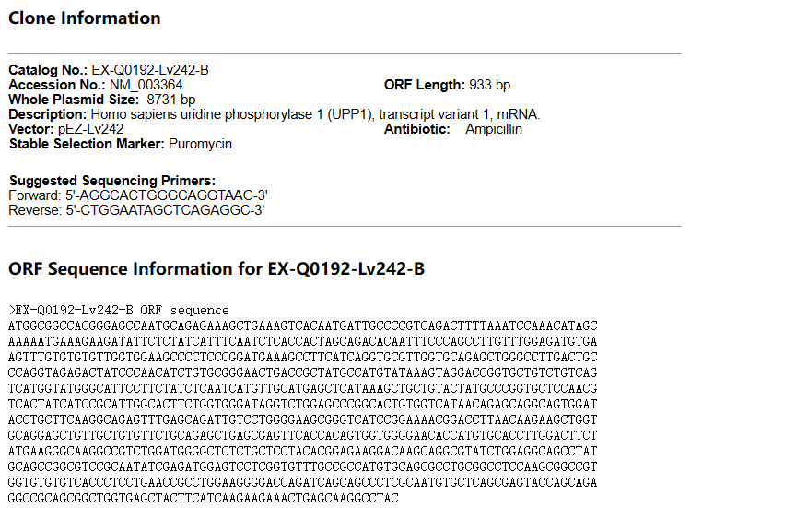

sh1-UPP1
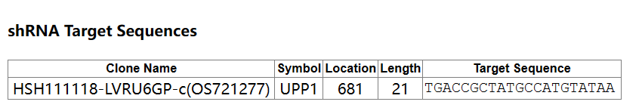
sh2-UPP1
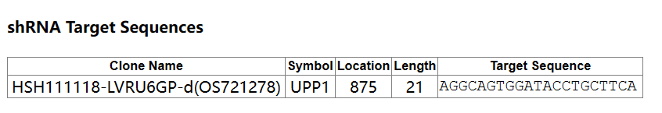
sh3-UPP1
