SUPPLEMENTAL FIGURES

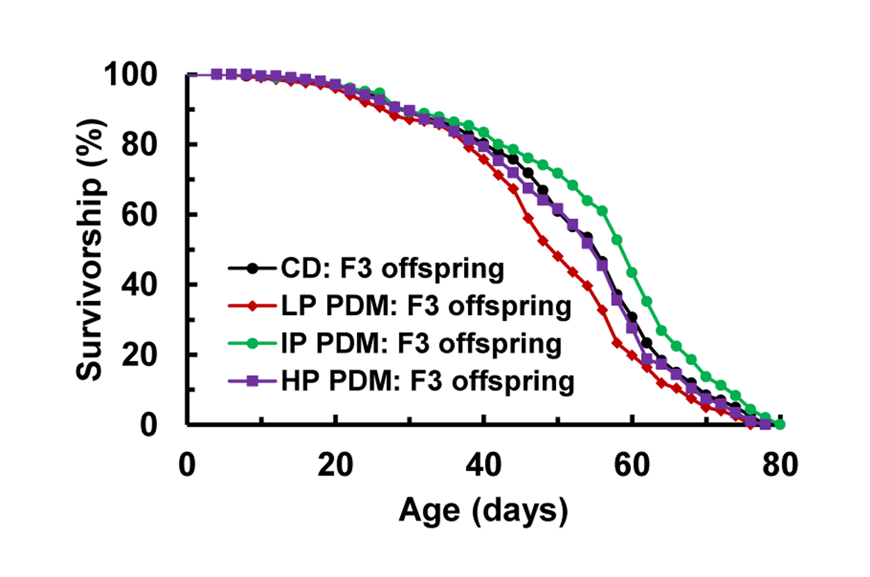

Supplemental Figure S2. Survival curves for the F3 generation (mated females only). The LP PDM of the F0 flies shortened longevity of their F3 offspring significantly (P = 0.003; Mantel-Cox test), or by 11% at the median lifespan (50 vs. 56 for LP vs. CD); while the IP PDM of the F0 flies improved longevity of their F3 offspring (P = 0.005), or 7% at the median lifespan (60 vs. 56 for IP vs. CD). The HP PDM of F0 flies induced no effect on F3 offspring any further (P = 0.46; 56 vs. 56 for median lifespan).

www.impactaging.com 1 AGING, March 2016, Vol. 8 No.3

SUPPLEMENTAL FIGURES

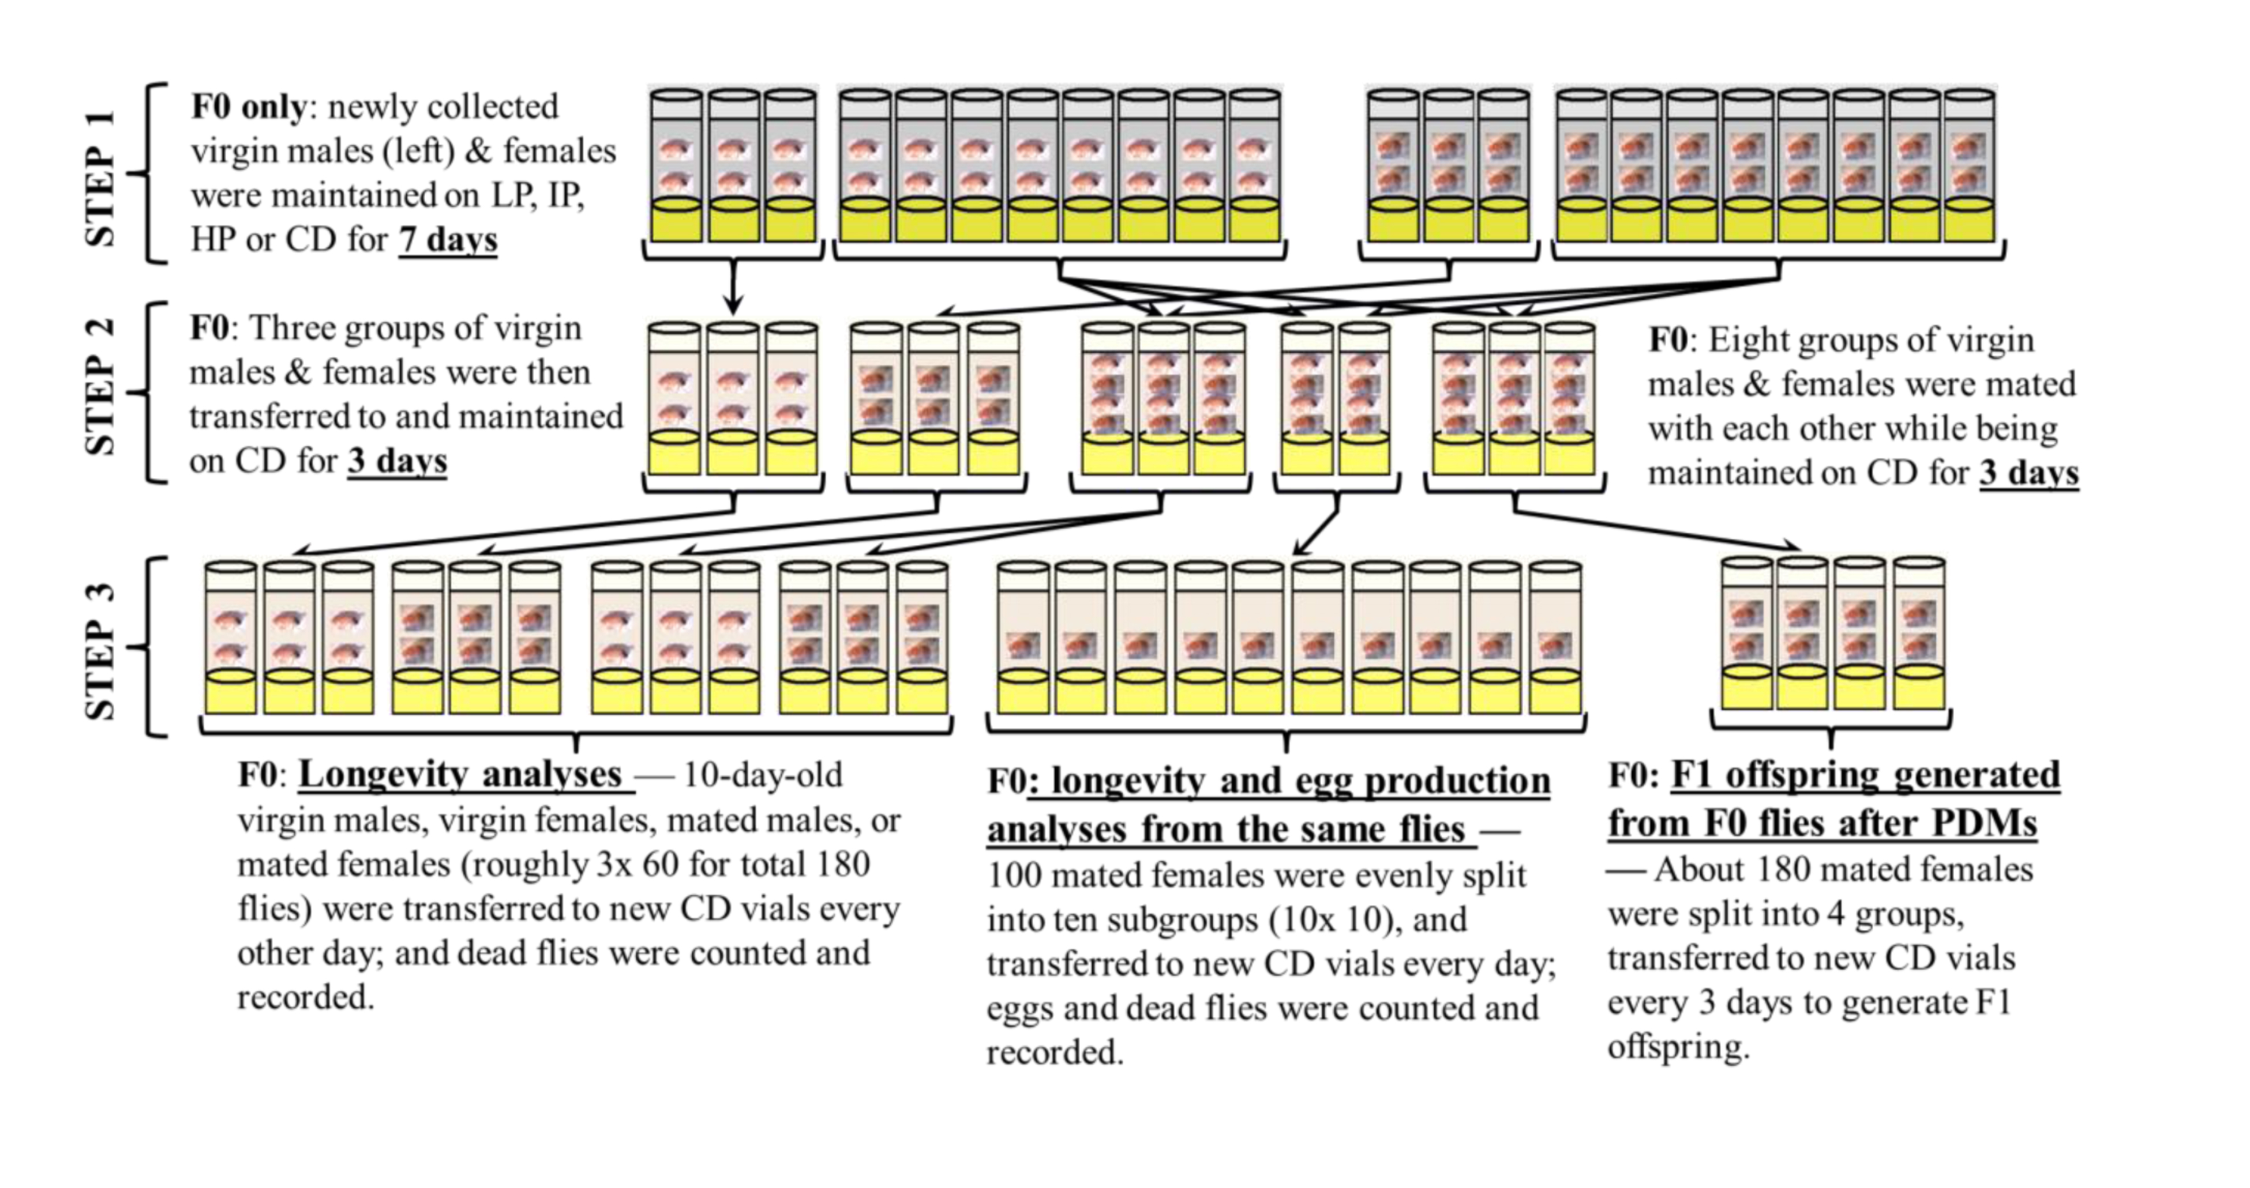

Supplemental Figure S1. Experimental design and procedures. Shown here is the F0 generation, subjected to the 7-day PDMs before longevity and fecundity analyses. STEP 1) Virgin males and females were collected and subjected to 7-day PDMs. STEP 2) Three groups of 60 virgin males and females were transferred to CD for 3 days, while the others (8 groups) were mated with each other for 3 days on CD. STEP 3) Longevity analyses: three groups (~180 flies) of virgin males, virgin females, mated males, and mated females were used; egg production and longevity analyses from same flies: 100 mated females were evenly split into 10 subgroups (10x10) and used for analyses; F1 offspring generated from the F0 flies after PDMs: 180 mated females were split into 4 groups and used for generating the F1 offspring while being maintained on CD all the time. Similar analyses were done with their F1, F2, and F3 offspring, by repeating STEPs 2−3 (i.e., without PDMs from STEP 1) as for the F0 parents while using newly-born virgin males and females, except that roughly 4x 50 flies were used for longevity analyses of the F2−F3 offspring.

Supplemental Figure S3. Eggs produced per day and 5-day period. (A) Average number of “Eggs Produced per Day” (1st row) and (B) “Fecundity per 5-day Period” (2nd row); and (0) F0 parents (1st column), (1) F1 offspring (2nd column), and (2) F2 offspring (3rd column) by the 100 mated females. “Eggs Produced per Day” was calculated as “total eggs produced for a given day divided by the number (1–100) of the surviving flies within a diet group”. “Fecundity per 5-day Period” was defined as the average number of eggs laid over a 5-day period by one mated female.

www.impactaging.com 2 AGING, March 2016, Vol. 8 No.3

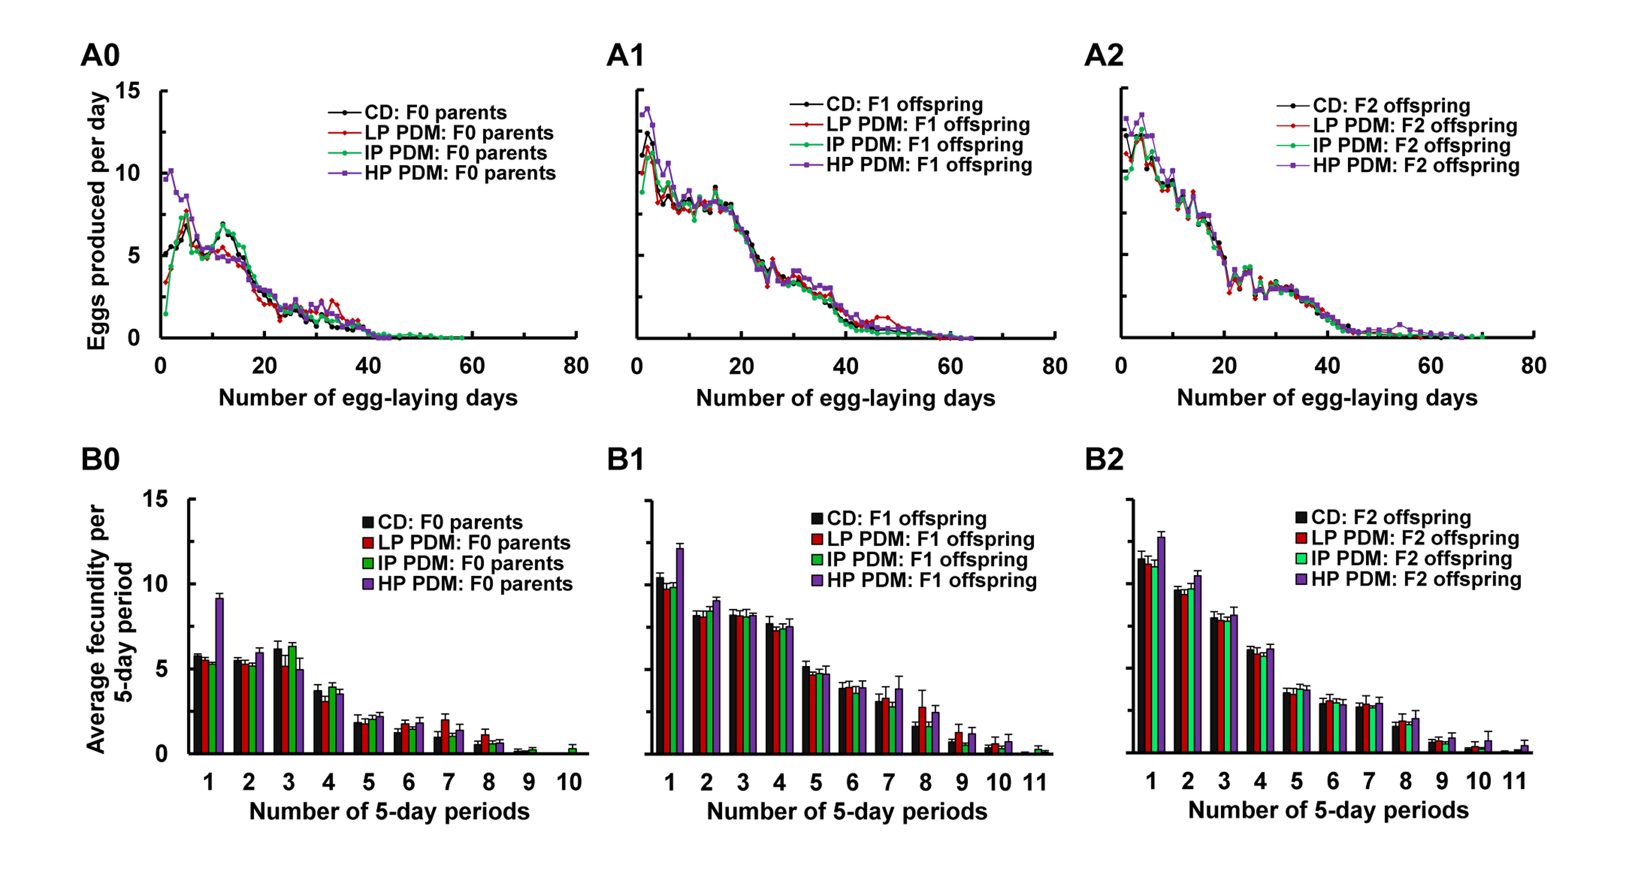

SUPPLEMENTAL TABLES

Supplemental Table S1. Diets used for the PDMs of the F0 parents.

 | Ingredients | Control diet (CD) ^{A} | LP diet ^{B} | IP diet ^{C} | HP diet ^{D}
Recipes | Yellow cornmeal (gm) | 76.6 | 98.0 | 92.0 | 162.5
 | Yeast (gm) | 32.1 |  | 17.2 | 33.5
 | Agar (gm) | 9.3 | 10.0 | 5.2 | 7.5
 | Glucose (gm) | 63.2 | 150.0 | 147.4
 | Sucrose (gm) | 31.6 |  |  | 40.0
 | CaCl2 (gm) | 0.7
 | Soy flour (gm) |  |  |  | 30.0
 | Water (gm) | 1000 | 1000 | 1000 | 1000
Total (gm, with water) |  | 1213.5 | 1258.0 | 1261.8 | 1273.5
Protein (%; with water) ^{E} |  | 8.6 | 3.3 | 5.5 | 13.5
Carbohydrate (%; with water) ^{E} |  | 76.6 | 90.5 | 87.4 | 69.6
Total calories ^{E} |  | 758.0 | 969.4 | 973.6 | 982.6
Calories per gram ^{F} |  | 0.62 | 0.77 | 0.77 | 0.77
Provided are the recipes, along with the protein, carbohydrate, and calorie information for the control diet (CD) and 3 other diets used for the PDMs of the F0 parents. (A) CD is a food medium routinely used in the lab. (B) The “LP” (Low Protein) diet was adapted from Xia et al [28]. (C) The “IP” (Intermediate Protein) diet was adapted from Guo et al [27]. (D) The “HP” (High Protein) diet was adapted from a widely used “standard diet” as described by Guo et al [27] and at Bloomington Stock Center (http://flystocks.bio.indiana.edu/Fly_Work/media-recipes/bloomfood.htm). (E) The protein, carbohydrate, and calorie information for all the ingredients has been obtained from their labels or from http://nutritiondata.self.com/. (F) All three diet recipes were slightly modified to be isocaloric (0.77 calories/gm food).

www.impactaging.com 3 AGING, March 2016, Vol. 8 No.3

www.impactaging.com 4 AGING, March 2016, Vol. 8 No.3

Supplemental Table S2. Sample size (N) for four types of flies after each PDM across the F0−F3 generations in the longevity experiments.

 | PDM diets | F0 parents (+ PDM) | F1 offspring | F2 offspring | F3 offspring
Virgin males | CD (control) | 181 | 184 | 198 | −
 | LP (F0 only) | 183 | 182 | 202 | −
 | IP (F0 only) | 180 | 181 | 200 | −
 | HP (F0 only) | 182 | 180 | 201 | −
Virgin females | CD (control) | 180 | 183 | 201 | −
 | LP (F0 only) | 182 | 182 | 202 | −
 | IP (F0 only) | 184 | 178 | 203 | −
 | HP (F0 only) | 180 | 185 | 201 | −
Mated males | CD (control) | 181 | 180 | 199 | −
 | LP (F0 only) | 182 | 181 | 200 | −
 | IP (F0 only) | 179 | 181 | 201 | −
 | HP (F0 only) | 180 | 185 | 202 | −
Mated females | CD (control) | 185 | 183 | 199 | 202
 | LP (F0 only) | 183 | 181 | 203 | 202
 | IP (F0 only) | 182 | 183 | 200 | 205
 | HP (F0 only) | 181 | 182 | 201 | 203
Mated females (same flies also assayed for reproduction) | CD (control) | 100 | 100 | 100 | −
 | LP (F0 only) | 100 | 100 | 100 | −
 | IP (F0 only) | 100 | 100 | 100 | −
 | HP (F0 only) | 100 | 100 | 100 | −
Subtotal (per generation) |  | 3305 | 3311 | 3613 | 812
Total (whole study) |  |  | 11,041

Supplemental Table S3. Number of eggs recorded for each subgroup (10 flies) of the mated females from the F0 parents (with PDM) and their F1-F2 offspring.

 | PDM diets |  |  | F0 parents (+ PDM) |  | F1 offspring |  | F2 offspring
Mated females (10x subgroups of 10 flies; same flies also assayed for longevity) | CD (control) | Subgroup 1 |  | 1101 |  | 2037 |  | 2022
 |  | Subgroup 2 |  | 1139 |  | 2057 |  | 1961
 |  | Subgroup 3 |  | 1070 |  | 2072 |  | 2095
 |  | Subgroup 4 |  | 1192 |  | 2111 |  | 1982
 |  | Subgroup 5 |  | 1213 |  | 2040 |  | 1987
 |  | Subgroup 6 |  | 1088 |  | 2253 |  | 2060
 |  | Subgroup 7 |  | 1122 |  | 2096 |  | 2027
 |  | Subgroup 8 |  | 1034 |  | 2132 |  | 2096
 |  | Subgroup 9 |  | 1017 |  | 2123 |  | 2061
 |  | Subgroup 10 |  | 957 |  | 2160 |  | 2118
 |  | Mean ± SEM |  | 1093.3 ± 24.8 |  | 2108.1 ± 20.6 |  | 2040.9 ± 17.0
 |  | Total per generation |  | 10933 |  | 21081 |  | 20409
 | LP (F0 only) | Subgroup 1 |  | 916 |  | 2008 |  | 1854
 |  | Subgroup 2 |  | 902 |  | 1950 |  | 1796
 |  | Subgroup 3 |  | 769 |  | 1794 |  | 1926
 |  | Subgroup 4 |  | 899 |  | 1946 |  | 1947
 |  | Subgroup 5 |  | 1015 |  | 1853 |  | 1811
 |  | Subgroup 6 |  | 825 |  | 1891 |  | 1923
 |  | Subgroup 7 |  | 873 |  | 1719 |  | 1867
 |  | Subgroup 8 |  | 902 |  | 1996 |  | 1704
 |  | Subgroup 9 |  | 834 |  | 1859 |  | 1908
 |  | Subgroup 10 |  | 1014 |  | 1716 |  | 1731
 |  | Mean ± SEM |  | 894.9 ± 24.5 |  | 1873.2 ± 33.4 |  | 1846.7 ± 26.7
 |  | Total per generation |  | 8949 |  | 18732 |  | 18467
 | IP (F0 only) | Subgroup 1 |  | 1095 |  | 2150 |  | 2128
 |  | Subgroup 2 |  | 1287 |  | 2315 |  | 2165
 |  | Subgroup 3 |  | 1100 |  | 2252 |  | 2115
 |  | Subgroup 4 |  | 1127 |  | 2176 |  | 2089
 |  | Subgroup 5 |  | 1336 |  | 2205 |  | 2152
 |  | Subgroup 6 |  | 1187 |  | 2348 |  | 2196
 |  | Subgroup 7 |  | 1074 |  | 2168 |  | 2199
 |  | Subgroup 8 |  | 1242 |  | 2222 |  | 2161
 |  | Subgroup 9 |  | 1161 |  | 2062 |  | 1942
 |  | Subgroup 10 |  | 1237 |  | 2211 |  | 2213
 |  | Mean ± SEM |  | 1184.6 ± 28.0 |  | 2210.9 ± 25.9 |  | 2136.0 ± 24.8
 |  | Total per generation |  | 11846 |  | 22109 |  | 21360
 | HP (F0 only) | Subgroup 1 |  | 1061 |  | 2288 |  | 2154
 |  | Subgroup 2 |  | 1214 |  | 2148 |  | 2163
 |  | Subgroup 3 |  | 1180 |  | 2168 |  | 2130
 |  | Subgroup 4 |  | 1083 |  | 2163 |  | 2256
 |  | Subgroup 5 |  | 1321 |  | 2199 |  | 2177
 |  | Subgroup 6 |  | 1140 |  | 2292 |  | 1952
 |  | Subgroup 7 |  | 1121 |  | 2132 |  | 2183
 |  | Subgroup 8 |  | 1217 |  | 2172 |  | 2052
 |  | Subgroup 9 |  | 1298 |  | 2076 |  | 2057
 |  | Subgroup 10 |  | 1100 |  | 2257 |  | 1992
 |  | Mean ± SEM |  | 1173.5 ± 28.1 |  | 2189.5 ± 22.2 |  | 2111.6 ± 30.1
 |  | Total per generation |  | 11735 |  | 21895 |  | 21116
Subtotal (per generation across four diets) |  |  | 43463 |  | 83817 |  | 81352
Total (whole study) |  |  | 208,632

www.impactaging.com 5 AGING, March 2016, Vol. 8 No.3

