**SUPPLEMENTARY DATA**

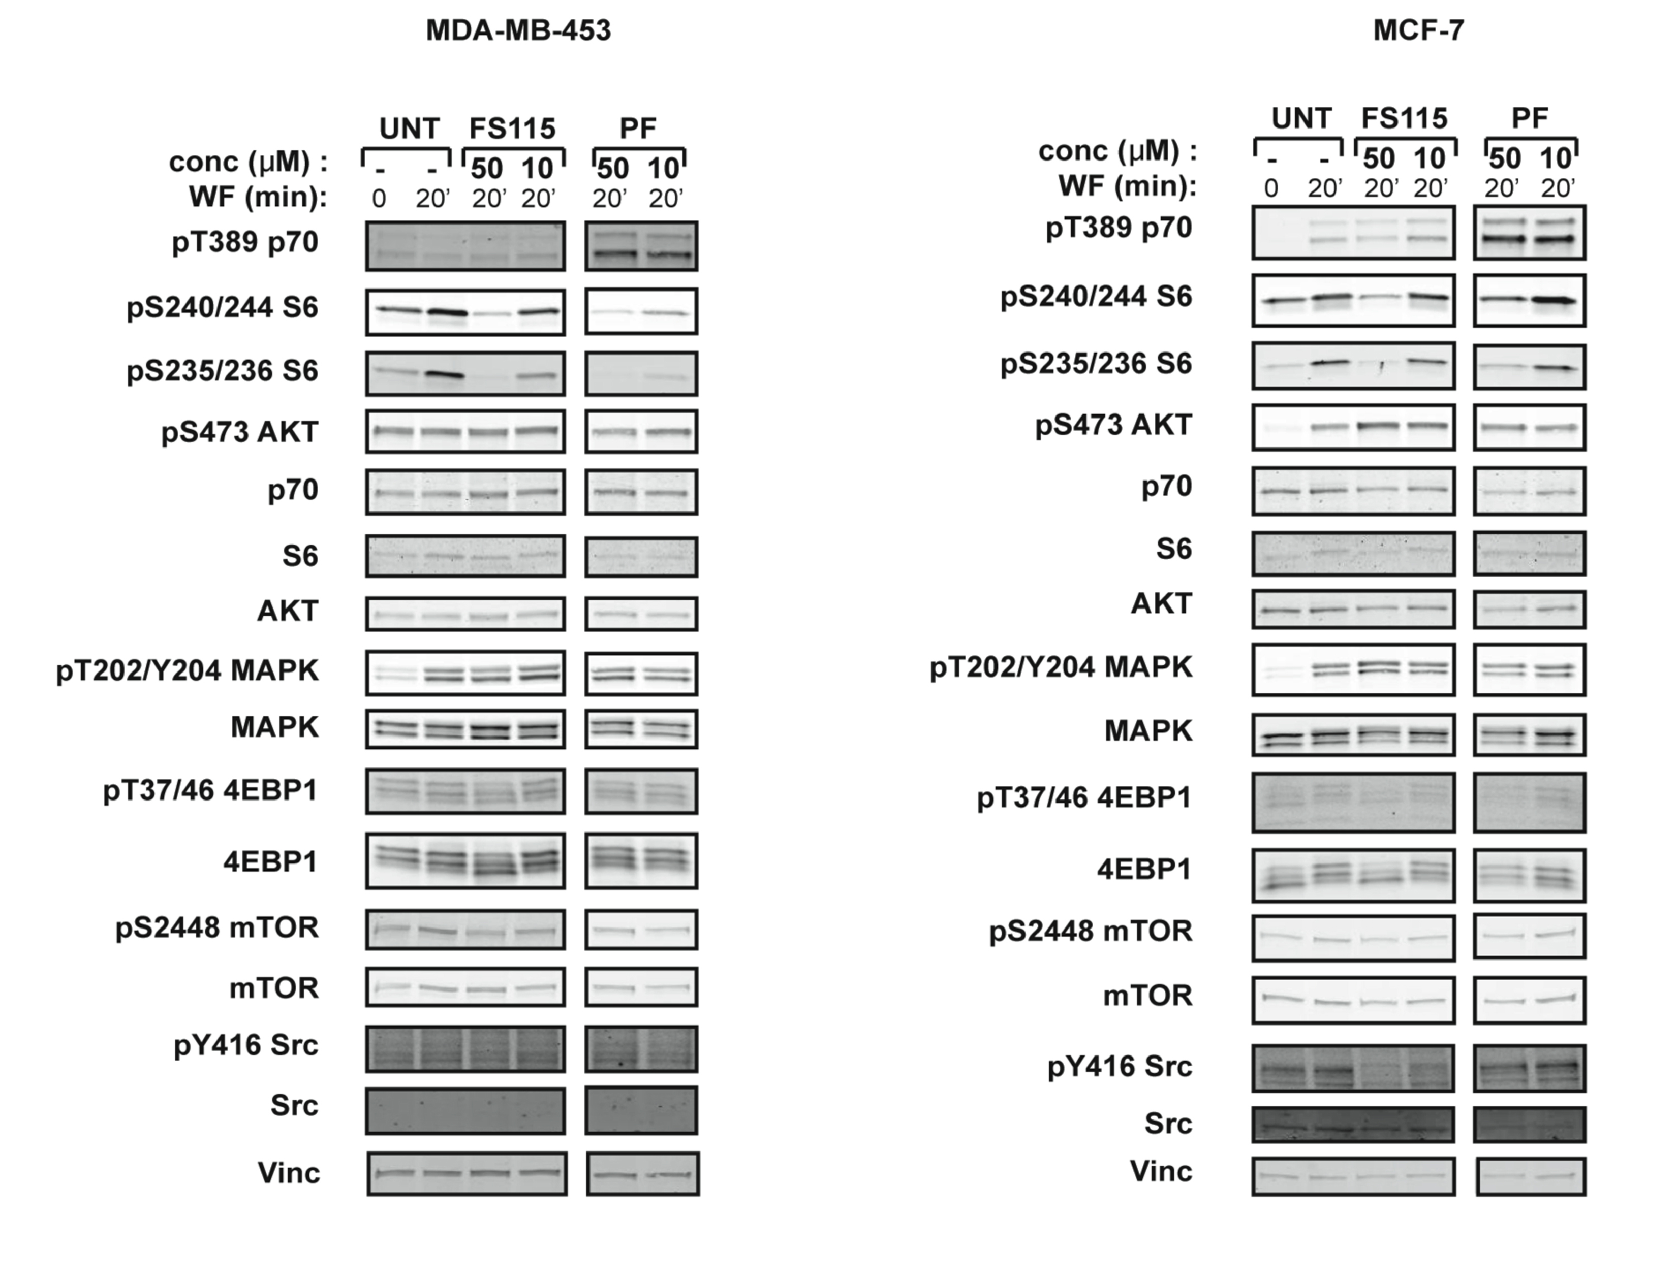

**Supplementary Figure S1. FS-115 inhibits p70S6K1 in different breast cancer cell lines.** (**A**)Western blot analysis of MDA-MB-453 breast cancer cells, serum starved (time 0) and then stimulated for 20 minutes with wound fluids (WF) or serum starved, pre-treated 30 minutes with FS-115 or PF-4708671 (50-10-5-1μM, as indicated) then stimulated for 20 minutes with WF, always in the presence of the inhibitor. p70S6K, AKT, MAPK, mTOR and Src signalling pathways were analyzed. Vinculin was used as loading control. (**B**) Same as in (**A**) but in MCF-7 breast cancer cells.

www.impactaging.com 1 AGING, May 2016, Vol. 8 No.5

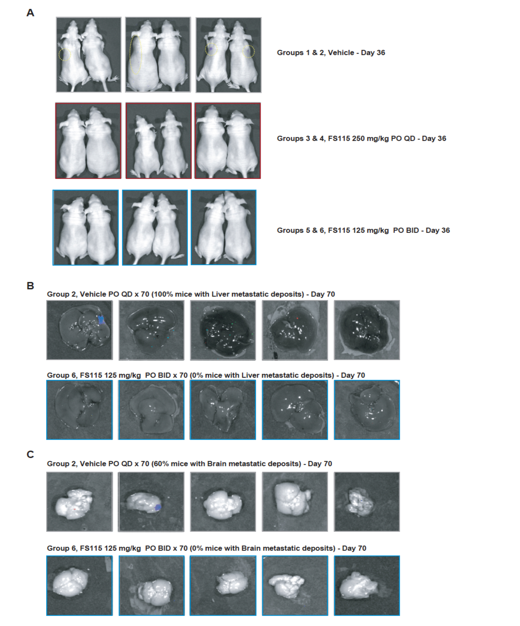

**Supplementary Figure S2. FS-115 efficiently counteracts metastatic spread to distant organs.** (**A**) Pictures show all animals from the experiment described in Figure 5 (except those reported in Figure 5), imaged using a Xenogen IVIS machine, after injection with D-luciferin, at day 36 from injection. (**B**) Pictures show livers from mice of two representative groups (Group 2, Vehicle QD, 70 days; and Group 6, FS-115 125mg/kg, BID, 70 days), from the experiment described in Figure 6. Mice were injected with D-luciferin before being culled, and then livers imaged using a Xenogen IVIS machine. (**C**) Same as in (**B**) except that brains were imaged.

www.impactaging.com 2 AGING, May 2016, Vol. 8 No.5

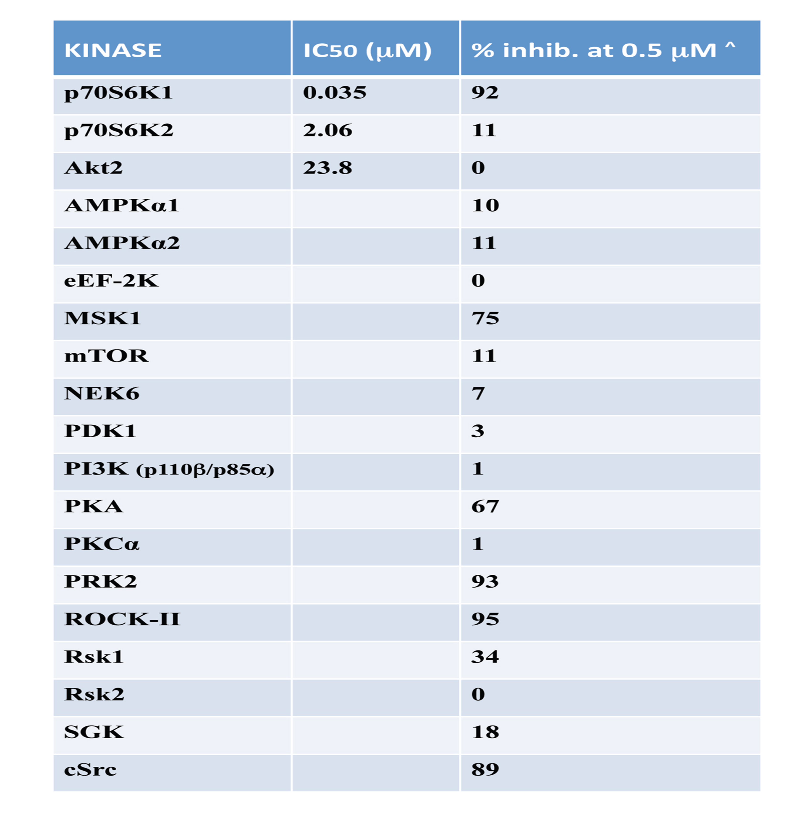

**Supplementary Table S1. Inhibition of key kinases by FS-115.** Table displays the IC50 (μM) and the percentage of inhibition of the indicated kinases, from the 268 tested in radiometric ATP-competitive kinase assay, using FS-115 at 0.5μM. Percentage inhibition represents the mean derived from a duplicate experiment.

www.impactaging.com 3 AGING, May 2016, Vol. 8 No.5