**SUPPLEMENTAL DATA**

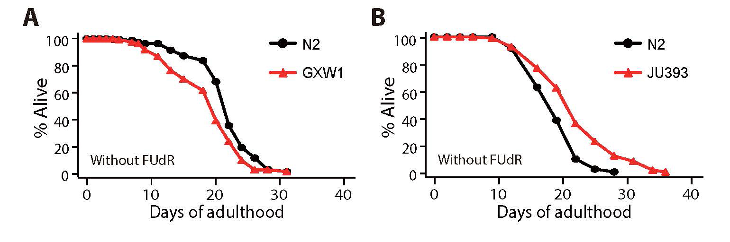

**Figure S1. Lifespan of N2, GXW1 and JU393 without FUdR treatment.** (**A**) Lifespan of GXW1, which displayed the shortest mean lifespan among wild *C. elegans* strains upon FUdR treatment (Fig. 1A), was shorter than N2 without FUdR treatment (2 out of 3 trials). (**B**) JU393, which displayed the longest mean lifespan among wild *C. elegans* upon FUdR treatment (Fig. 1A), lived longer than N2 without FUdR treatment (2 out of 2 trials). See Table S2 for statistical analysis.

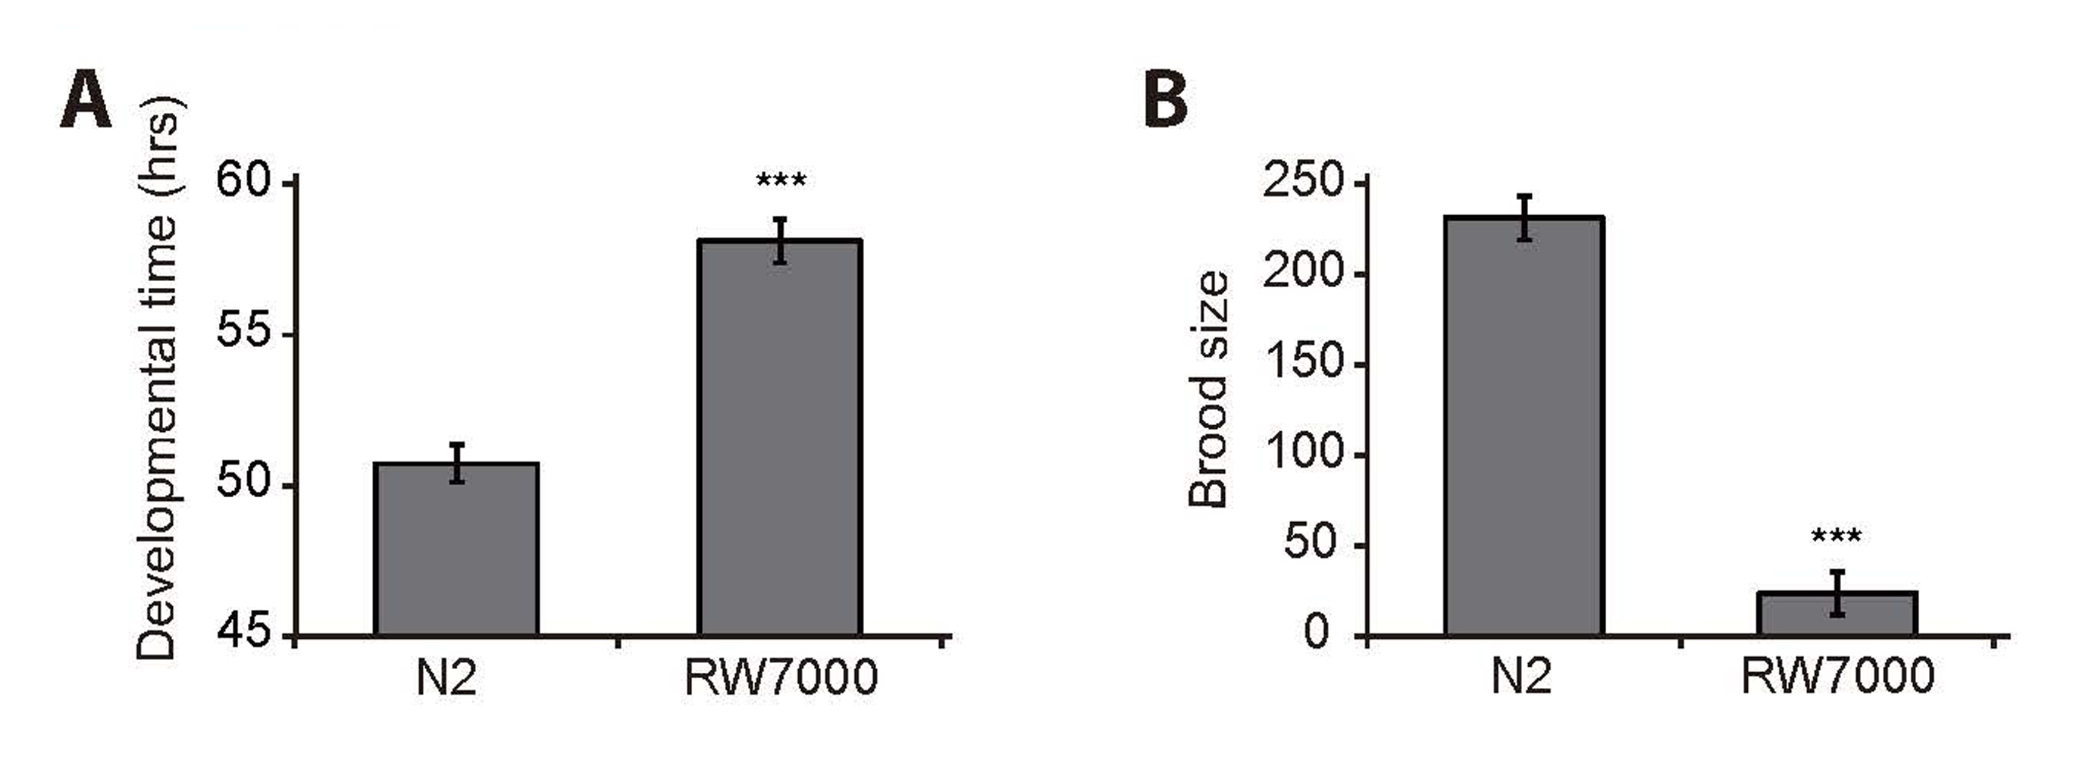

**Figure S2. RW7000 displays slow development and semi-sterility.** The developmental time (**A**) (n = 67) and the brood size (**B**) (n = 8) of RW7000 were compared with N2 at least twice independently. Error bars represent standard error of mean (s.e.m.) (two-tailed Student’s *t*-test, \*\*\**p* < 0.001).

www.impactaging.com 1 AGING, May 2016, Vol. 8 No.5

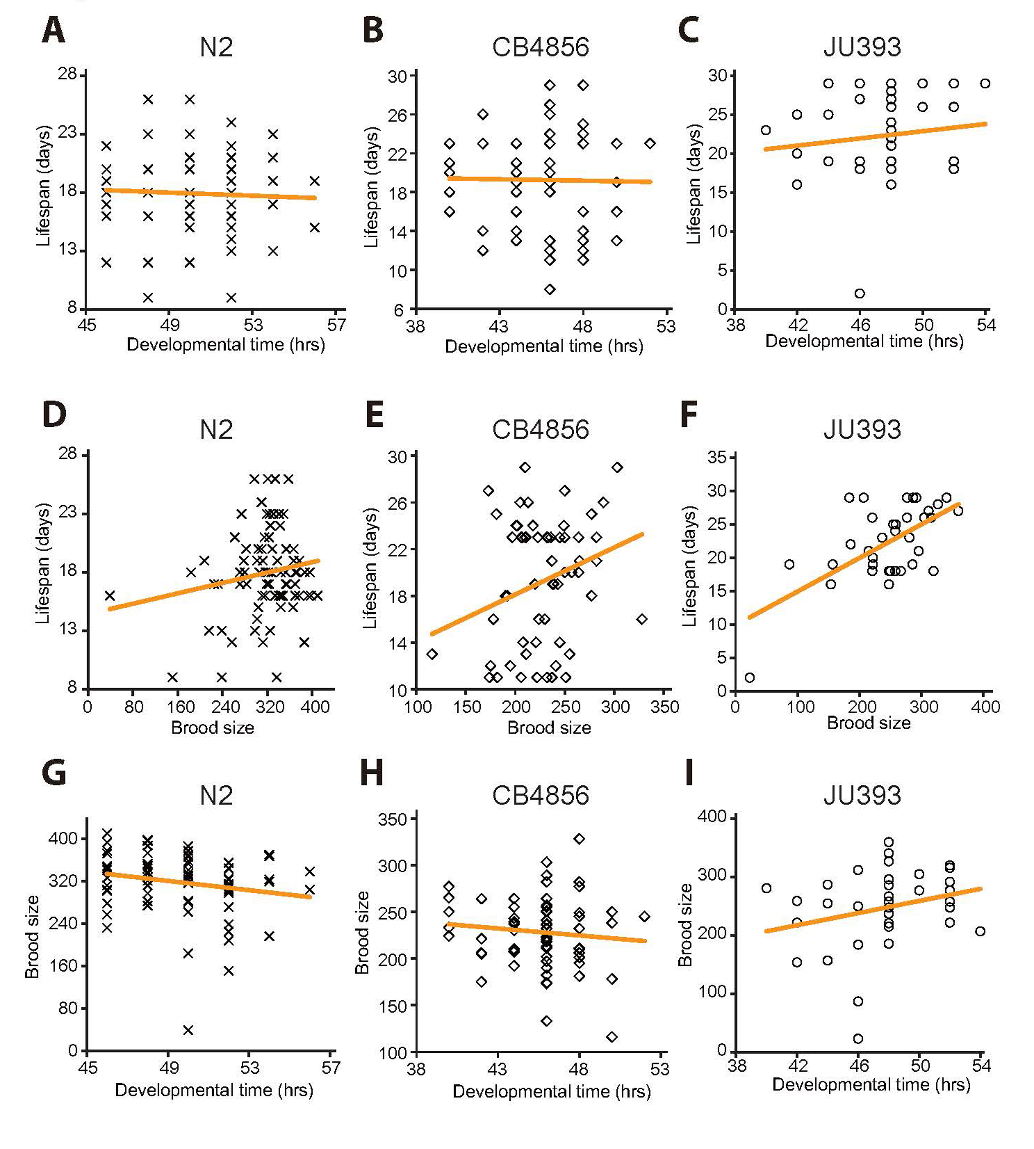

**Figure S3. Correlation analysis among developmental time, brood size, and lifespan using individuals of isogenic N2, CB4856, and JU393 strains.** (**A**-**C**) Lifespan and developmental time among individuals of N2 (**A**; *r* = -0.047, *p* = 0.675), CB4856 (**B**; *r* = -0.015, *p* = 0.907), or JU393 (**C**; *r* = 0.141, *p* = 0.420) did not display a significant correlation. (**D**-**F**) Lifespan did not correlate with brood size among individuals of N2 (**D**; *r* = 0.176, *p* = 0.114), whereas lifespan correlated with brood size among individuals of CB4856 (**E**; *r* = 0.280, *p* = 0.025) and JU393 (**F**; *r* = 0.619, *p* < 0.001). (**G**-**I**) Developmental time and brood size among individuals of N2 (**G**; *r* = -0.194, *p* = 0.081), CB4856 (**H**; *r* = -0.106, *p* = 0.407), or JU393 (**I**; *r* = 0.256, *p* = 0.138) did not display a significant correlation.

www.impactaging.com 2 AGING, May 2016, Vol. 8 No.5

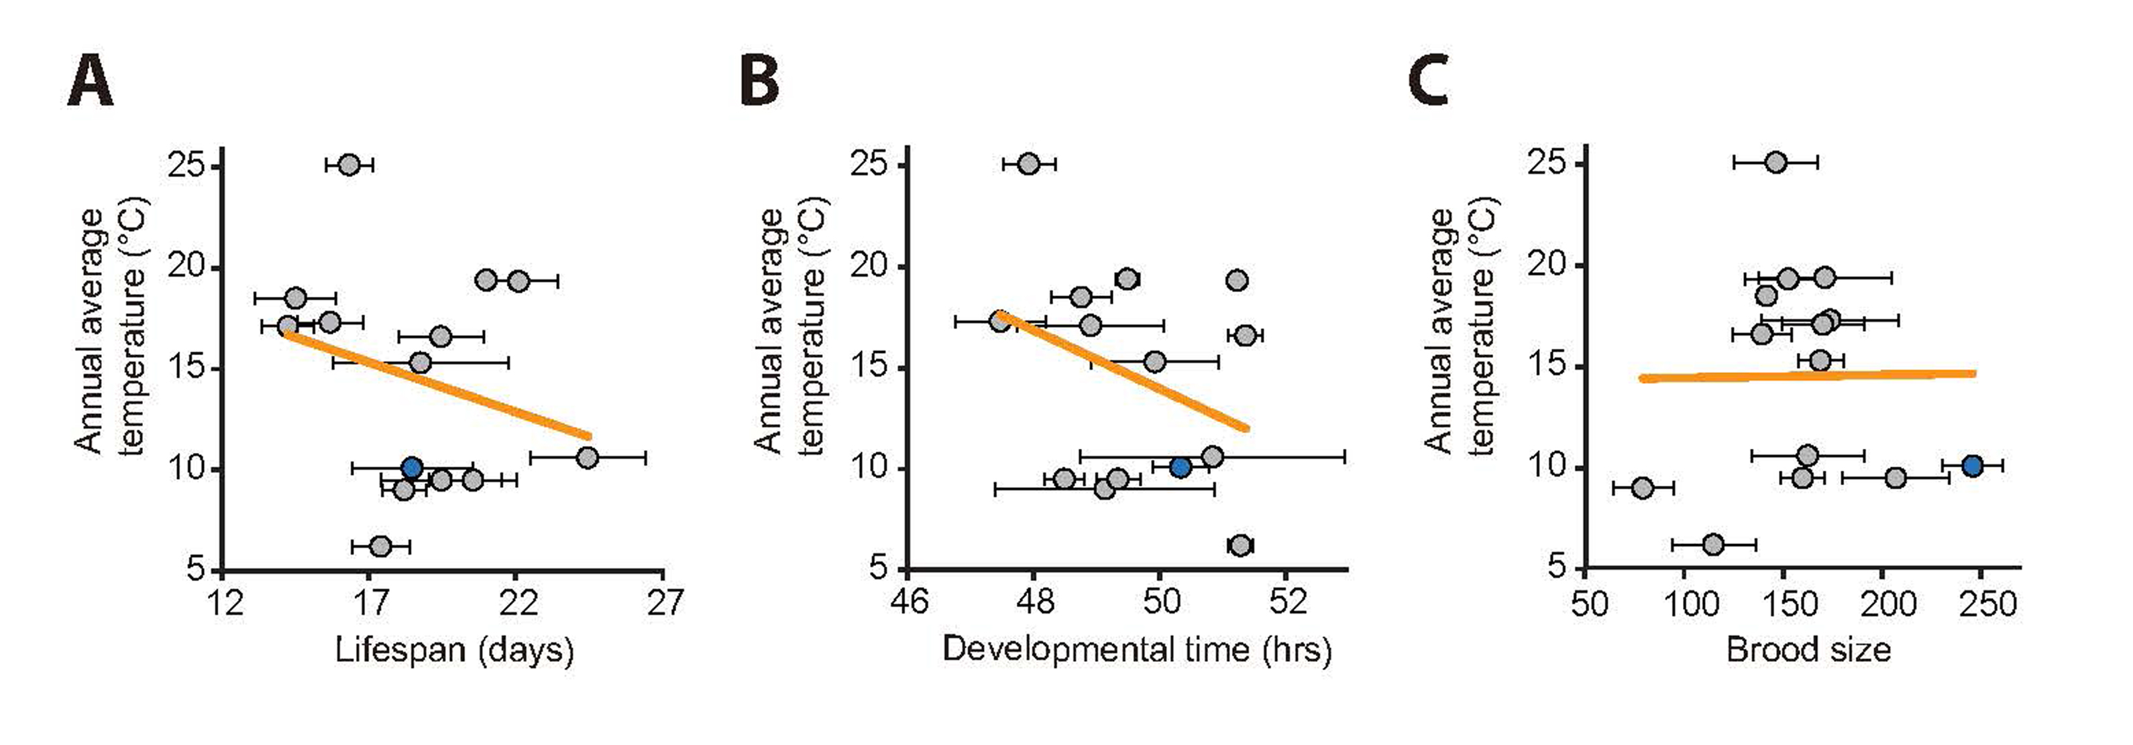

­**Table S1. Analysis of mean lifespan, developmental time, and brood size of the wild strains examined in this study**

|  |  |  |  |  |  |  |
| --- | --- | --- | --- | --- | --- | --- |
| **Strain** | **Mean lifespan ±s.e.m. (days)** | **Sum of animals that died/total (number of trials)** | **Mean develop-mental time ±s.e.m. (hrs)** | **Sum of animals that reached adults/ total (number of trials)** | **Mean brood size±s.e.m.** | **Total number of tested animals (number of trials)** |
| AB1 | 15.7±1.1 | 261/325 (3) | 47.5±0.7 | 75/80 (2) | 173.8±34.8 | 17 (3) |
| CB4853 | 19.5±1.4 | 226/296 (3) | 51.4±0.3 | 79/80 (2) | 139.5±14.8 | 20 (3) |
| CB4856 | 16.3±0.8 | 266/325 (3) | 47.9±0.4 | 53/80 (2) | 146.5±21.3 | 22 (3) |
| CB4857 | 14.5±1.4 | 283/317 (3) | 48.8±0.5 | 58/80 (2) | 141.7±4.5 | 21 (3) |
| CB4858 | 21.0±0.2 | 191/296 (3) | 49.5±0.2 | 78/80 (2) | 171.3±33.6 | 13 (3) |
| ED3053 | 18.8±3.0 | 214/360 (3) | 49.9±1.0 | 66/80 (2) | 169.0±11.4 | 13 (3) |
| GXW1 | 14.3±0.9 | 265/327 (3) | 48.9±1.2 | 80/80 (2) | 170.2±20.6 | 23 (3) |
| JU258 | 22.1±1.3 | 201/295 (3) | 51.2±0.1 | 75/80 (2) | 152.7±21.8 | 16 (3) |
| JU393 | 24.5±2.0 | 262/420 (4) | 50.9±2.1 | 80/80 (2) | 162.7±28.1 | 18 (3) |
| MY1 | 18.2±0.7 | 209/285 (3) | 49.1±1.7 | 77/80 (2) | 79.3±15.3 | 19 (3) |

**Figure S4. Correlation analysis among mean lifespan, developmental time, brood size and average annual temperatures of the regions where wild *C. elegans* strains originated.** Average annual temperature of each strain’s origin did not correlate with mean lifespan (**A**; *r* = -0.271, *p* = 0.330), developmental time (**B**; *r* =-0.340, *p* = 0.215), or brood size (**C**; *r* = 0.010, *p* = 0.972). Error bars indicate the standard error of mean (s.e.m.). *r* values are the Pearson correlation coefficients, and their *p* values were calculated by using statistical significance test (see Materials and Methods). Orange lines indicate linear regression lines. Data for ancestral N2 were shown as blue circles. See Table S3 for data values and statistical analysis for each strain.

www.impactaging.com 3 AGING, May 2016, Vol. 8 No.5

|  |  |  |  |  |  |  |
| --- | --- | --- | --- | --- | --- | --- |
| MY2 | 20.6±1.5 | 198/360 (3) | 48.5±0.3 | 78/80 (2) | 160.0±10.8 | 12 (3) |
| MY16 | 19.5±2.0 | 130/220 (2) | 49.4±0.4 | 79/80 (2) | 207.1±26.9 | 20 (3) |
| N2 | 19.0±0.8 | 968/1160 (11) | 50.7±0.6 | 80/80 (2) | 231.4±12.1 | 69 (10) |
| N2* | 18.5±2.0 | 224/300 (3) | 50.3±0.4 | 80/80 (2) | 245.8±15.0 | 20 (3) |
| PB303 | 18.0±0.3 | 134/200 (2) | 48.2±0.6 | 77/80 (2) | 209.1±23.9 | 14 (3) |
| TR403 | 17.4±1.0 | 269/310 (3) | 51.3±0.2 | 77/80 (2) | 114.9±21.1 | 23 (3) |

N2*: ancestral N2

­­­**Table S2. Lifespan analysis of N2, GXW1 and JU393 strains without FUdR treatment**

|  |  |  |  |  |  |
| --- | --- | --- | --- | --- | --- |
| **Strain** | **Mean lifespan ±s.e.m. (days)** | **75th percentile** | **% change** | **Number of animals that died/total** | ***p* value vs. N2** |
| N2 | 14.4±0.5 | 17 |  | 68/150 |  |
| GXW1 | 12.5±0.6 | 17 | -13% | 54/180 | 0.0133 |
| N2 | 21.6±0.4 | 24 |  | 127/180 |  |
| GXW1 | 18.8±0.6 | 22 | -13% | 74/150 | 0.0001 |
| JU393 | 24.0±0.4 | 26 | +11% | 91/150 | 0.0001 |
| N2 | 18.3±0.4 | 22 |  | 115/180 |  |
| GXW1 | 18.4±0.5 | 20 | +1% | 94/150 | 0.8901 |
| JU393 | 24.5±0.7 | 28 | +34% | 71/150 | <0.0001 |

www.impactaging.com 4 AGING, May 2016, Vol. 8 No.5

**Table S3. Summary of information regarding wild *C. elegans* isolates that were tested in this study**

|  |  |  |  |  |
| --- | --- | --- | --- | --- |
| **Isolate** | **Location of origin** | **Latitude** | **Average summer temperature (°C, High, Low)** | **Average winter temperature (°C, High, Low)** |
| AB1 | Adelaide, Australia | 34° 93'S | 28, 18 | 14, 8 |
| CB4853 | Altadena, USA | 34° 11'N | 29.9, 14.3 | 17.9, 5.7 |
| CB4856 | Hawaii, USA | 21° 33'N | 27.3, 19.1 | 24.2, 15.5 |
| CB4857 | Claremont, USA | 34° 07'N | 32.2, 16.7 | 20.0, 6.1 |
| CB4858 | Pasadena, USA | 34° 09'N | 31.4, 15.5 | 19.1, 5.8 |
| ED3053 | Limuru, Kenya | 1° 05'S | 25, 12 | 21, 11 |
| GXW1 | Wuhan, China | 30° 37'N | 32, 25 | 7, 0 |
| JU258 | Ribeiro Frio, Portugal | 32° 43'N | 24, 19 | 18, 14 |
| JU393 | Hermanville, France | 49° 17'N | 22, 13 | 7, 2 |
| MY1 | Lingen, Germany | 52° 54'N | 24, 13 | 6, 0 |
| MY16 | Mecklenbeck, Germany | 51° 56'N | 24, 13 | 6, 0 |
| MY2 | Roxel, Germany | 51° 96'N | 24, 13 | 6, 0 |
| N2 | Bristol, UK | 51° 28'N | 22, 14 | 8, 4 |
| N2 ancestral | Bristol, UK | 51° 28'N | 22, 14 | 8, 4 |
| TR403 | Madison, USA | 43° 04'N | 29, 16 | -1, -11 |

Note that the reference N2 strain, which may have been adapted to laboratory conditions, was excluded from correlation analysis between the annual average temperatures of strains’ regional origins and the life-history traits (mean lifespan, developmental time and brood size). We also excluded PB303, which does not have specific information about regional origin. Summer temperature represents the average temperature of January (Southern hemisphere) and July (Northern hemisphere), respectively. Conversely, winter temperature represents the average temparature of July (Southern hemisphere) and January (Northern hemisphere).

www.impactaging.com 5 AGING, May 2016, Vol. 8 No.5