SUPPLEMENTARY DATA

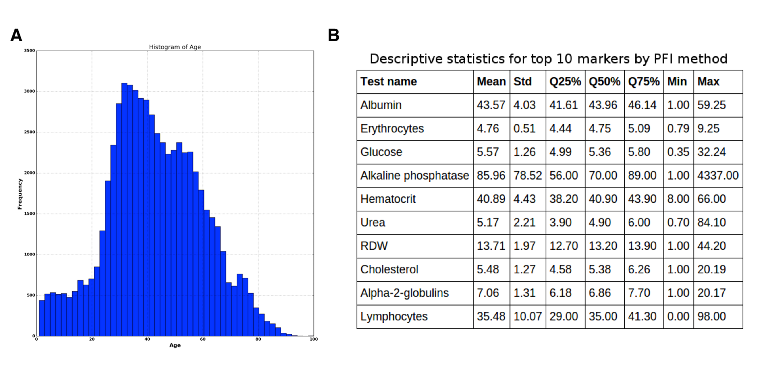

**Figure S1.** (**A**) Histogram of age distribution. (**B**) Table of descriptive statistic for top 10 markers.

**Table S1.** Table of hyperparameters.The best DNN in the ensemble has AdaGrad optimizer, PReLU activation function and 4 hidden layers with 2000, 1500, 1000, 500 neurons respectively and got 0.803 of *R2*.

|  |  |  |  |
| --- | --- | --- | --- |
| DNN architecture. Hidden units | Additional parameters. Activation function/Optimizer | | |
| ReLU/AdaDelta | ReLU/AdaGrad | PReLU/AdaGrad |
| 1000-1000-500 | 0.742 | 0.77 | 0.773 |
| 1000-1000-1000-500 | 0.745 | 0.782 | 0.792 |
| 1000-1000-1000-1000 | 0.75 | 0.784 | 0.785 |
| 1500-1500-1500-1500 | 0.754 | 0.791 | 0.795 |
| 2000-1500-1000-500 | 0.755 | 0.792 | **0.805** |
| 2500-2500-2500-2500 | 0.745 | 0.775 | 0.781 |

www.impactaging.com 1 AGING, May 2016, Vol. 8 No.5

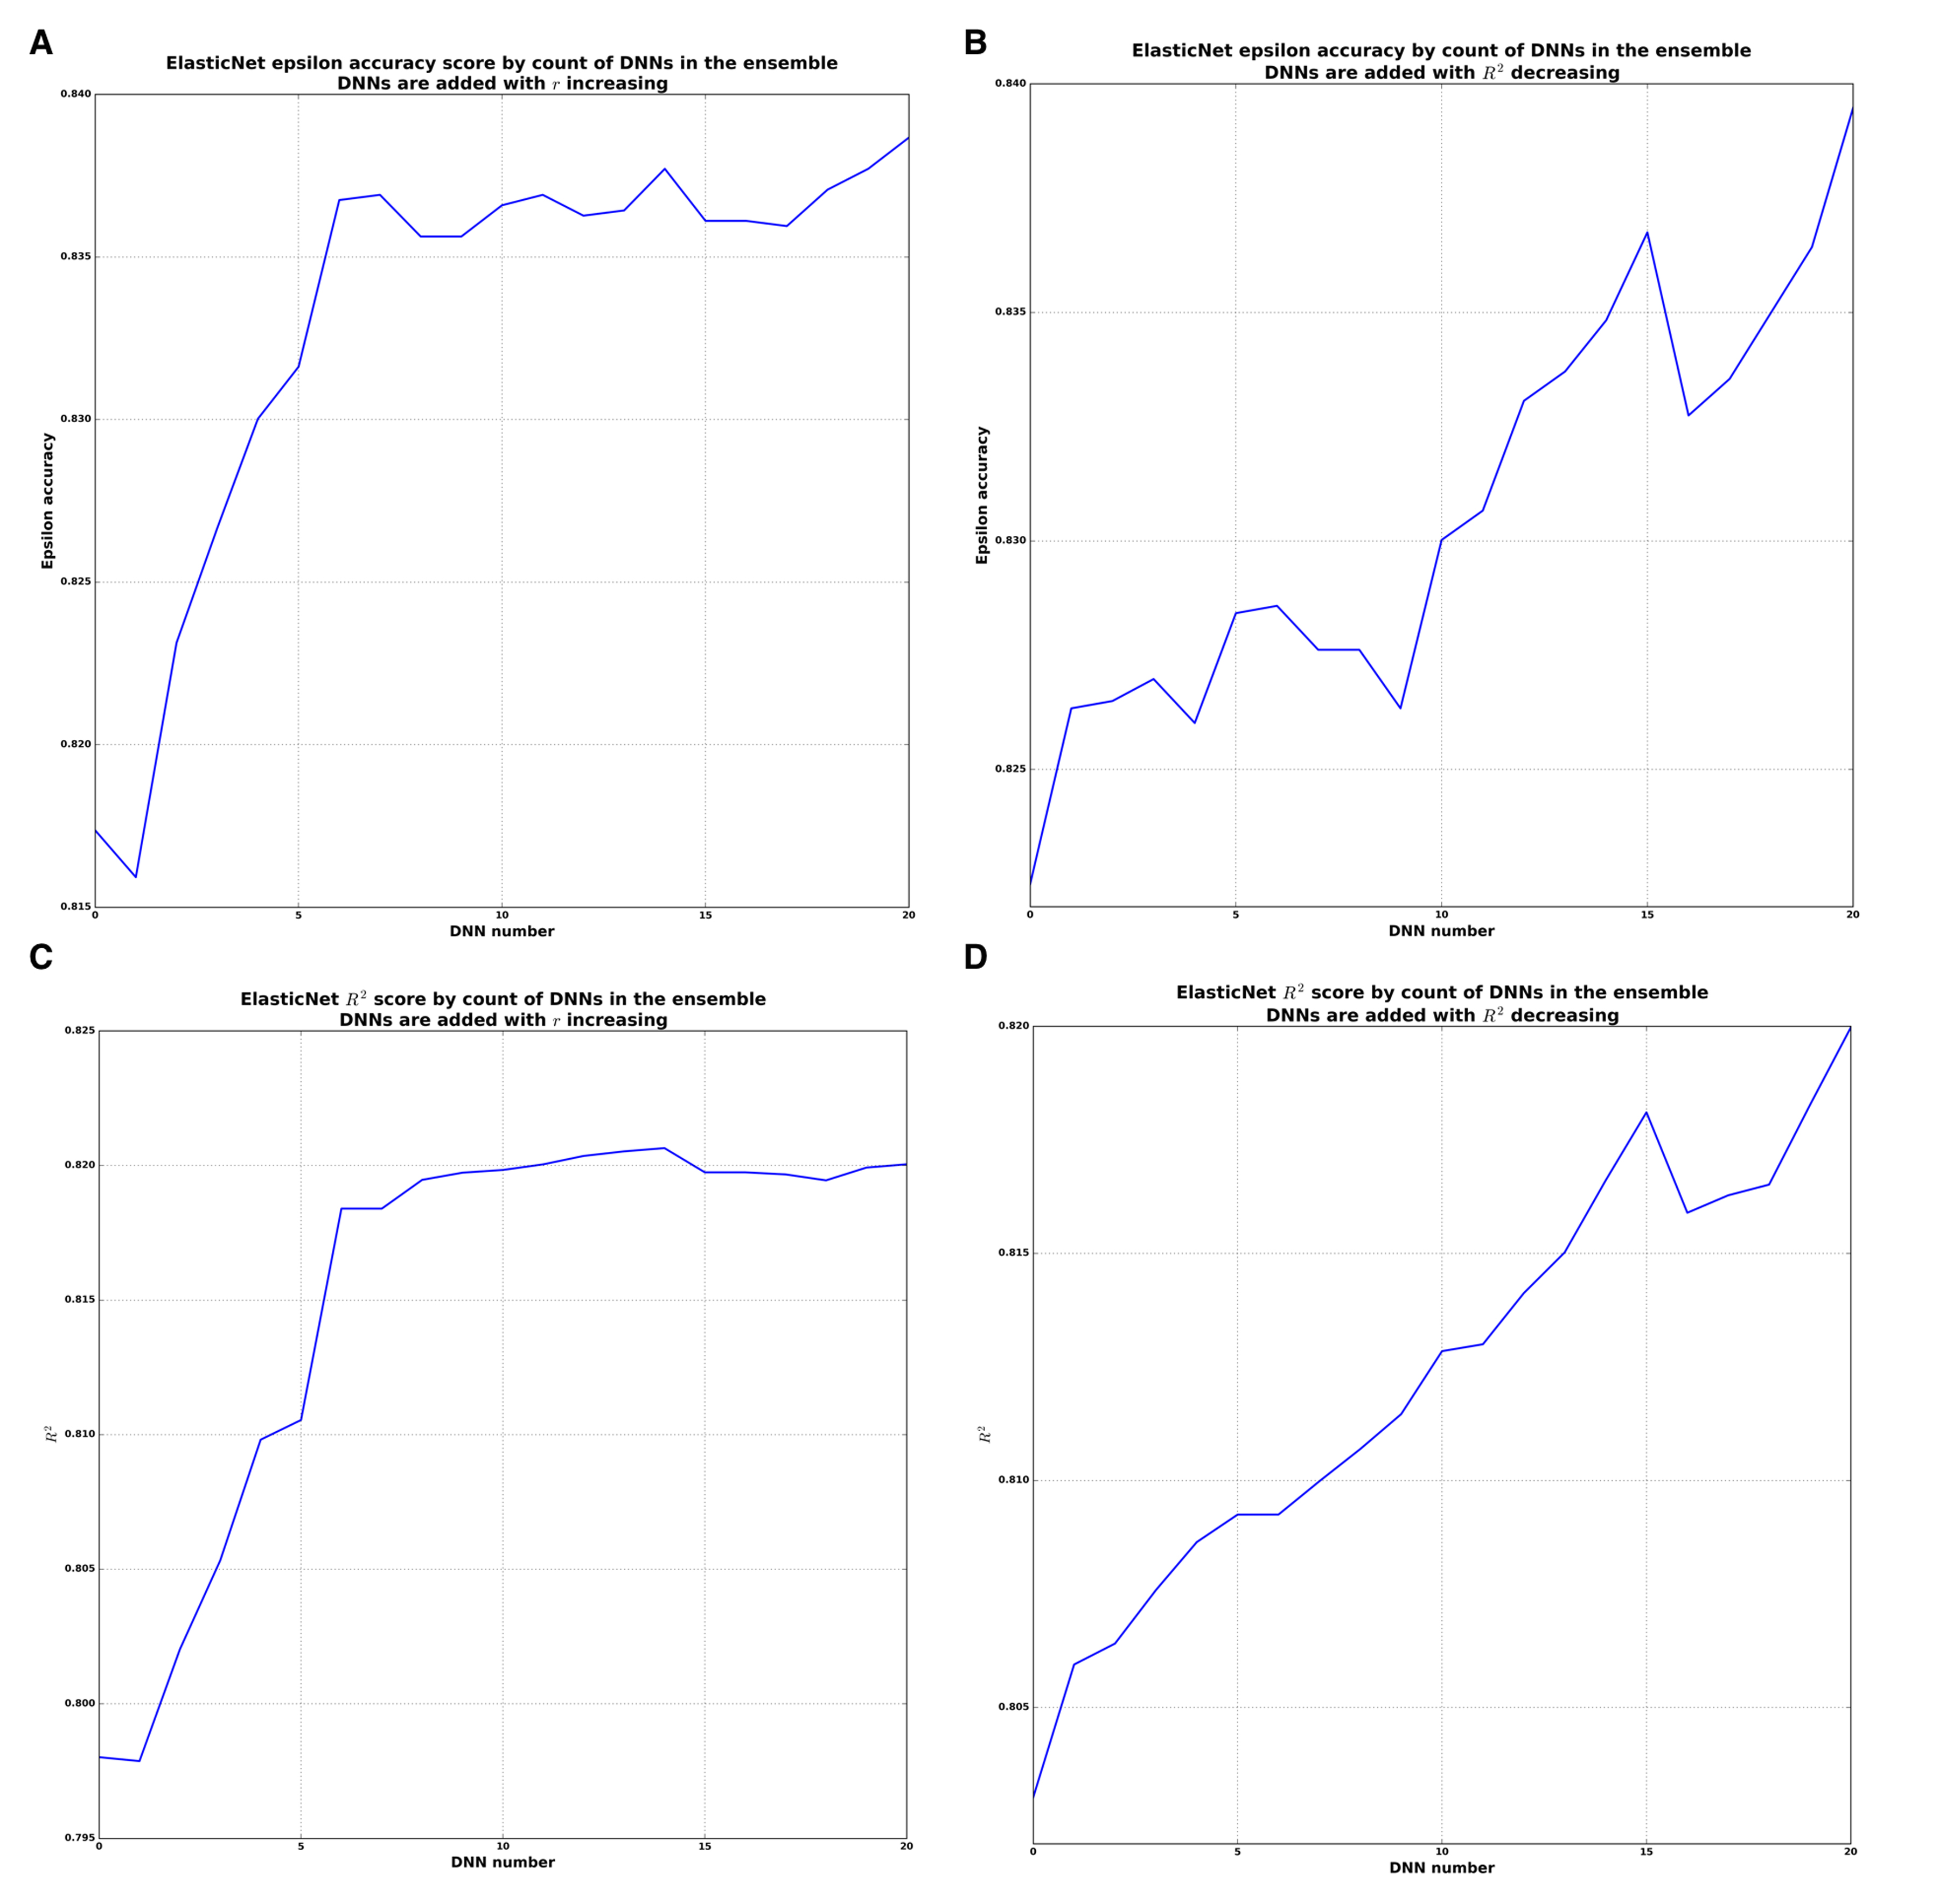

**Figure S2. Analysis of the ensemble based on ElasticNet model.** (**A**) Epsilon accuracy plot for constructing ensemble where DNNs are added with *r* increasing. (**B**) Epsilon accuracy plot for constructing ensemble where DNNs are added with *R2*decreasing. (**C**) *R2*plot for constructing ensemble where DNNs are added with r increasing. (**D**) *R2*plot for constructing ensemble where DNNs are added with *R2* decreasing,

www.impactaging.com 2 AGING, May 2016, Vol. 8 No.5

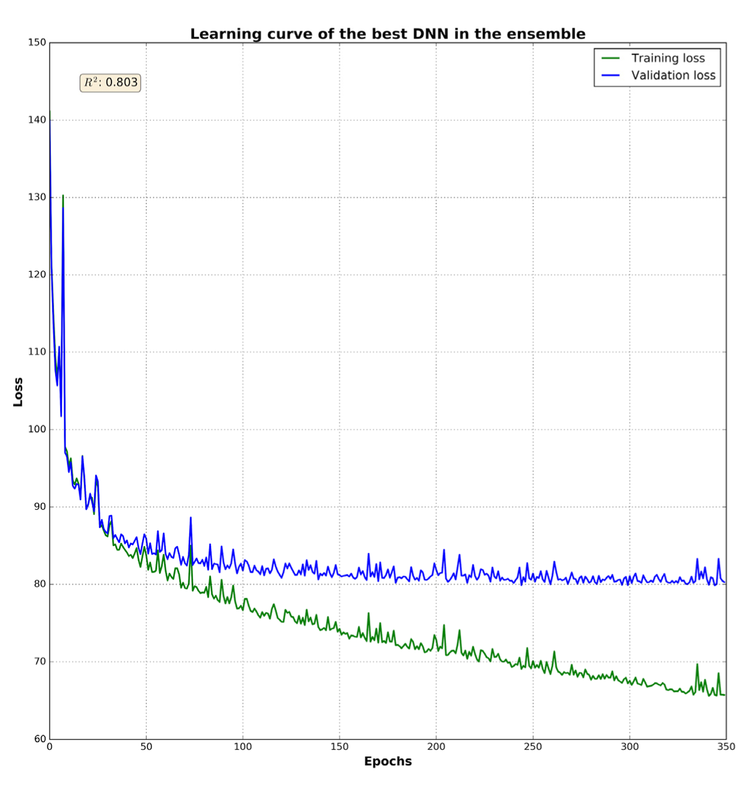

**Figure S3. Learning curve of the best DNN in the ensemble.** The green line is a training loss; blue is a validation loss. Training was stopped on 350 epoch because of reaching a plateau. The DNN got 0.803 of *R2*.

www.impactaging.com 3 AGING, May 2016, Vol. 8 No.5