**SUPPLEMENTARY DATA**

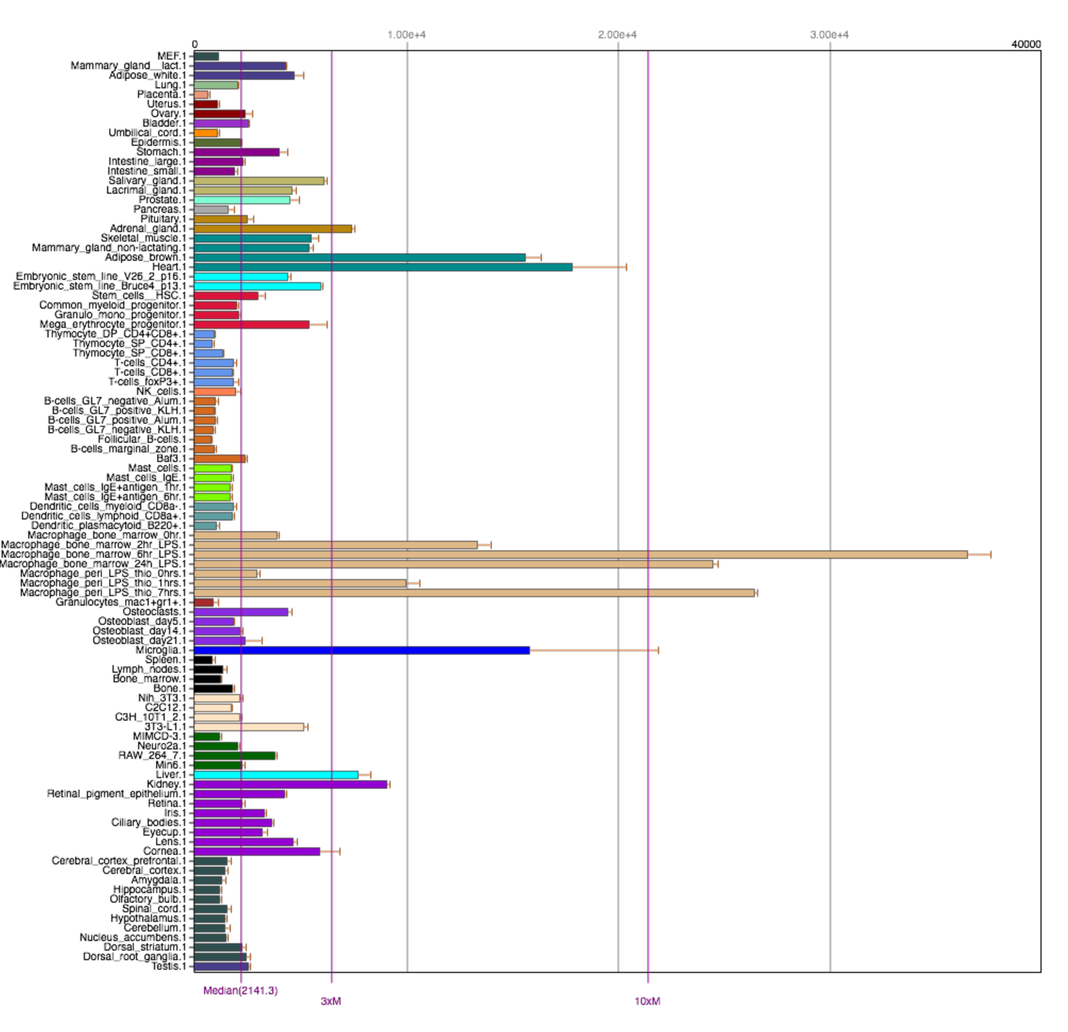

**Figure S1. Tissue-specific mRNA expression of SOD2.** Shown is mRNA expression of SOD2 in different mouse tissues. Data are generated from BioGPS (www.biogps.org).

www.impactaging.com 1 AGING, May 2016, Vol. 8 No.5

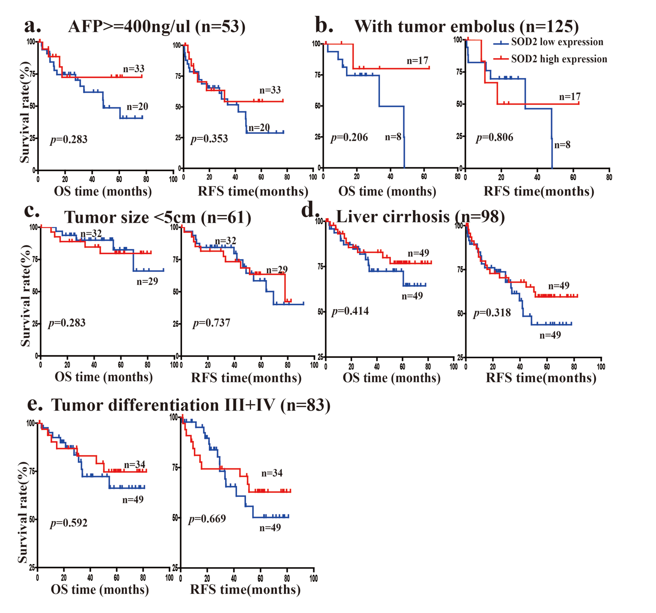

**Figure S2. Overall survival (OS) and relapse-free survival (RFS) in advanced HCC patients with different SOD2 protein expression.** The OS and RFS of 160 HCC patients with SOD2 high expression and low expression are analyzed in (**a**) patients with high AFP level (> 400 ng/μl), (**b**) patients without tumor embolus, (**c**) patients with tumor size < 5cm, (**d**) patients no liver cirrhosis, (**e**) patients with tumor differentiation III+IV.

www.impactaging.com 2 AGING, May 2016, Vol. 8 No.5

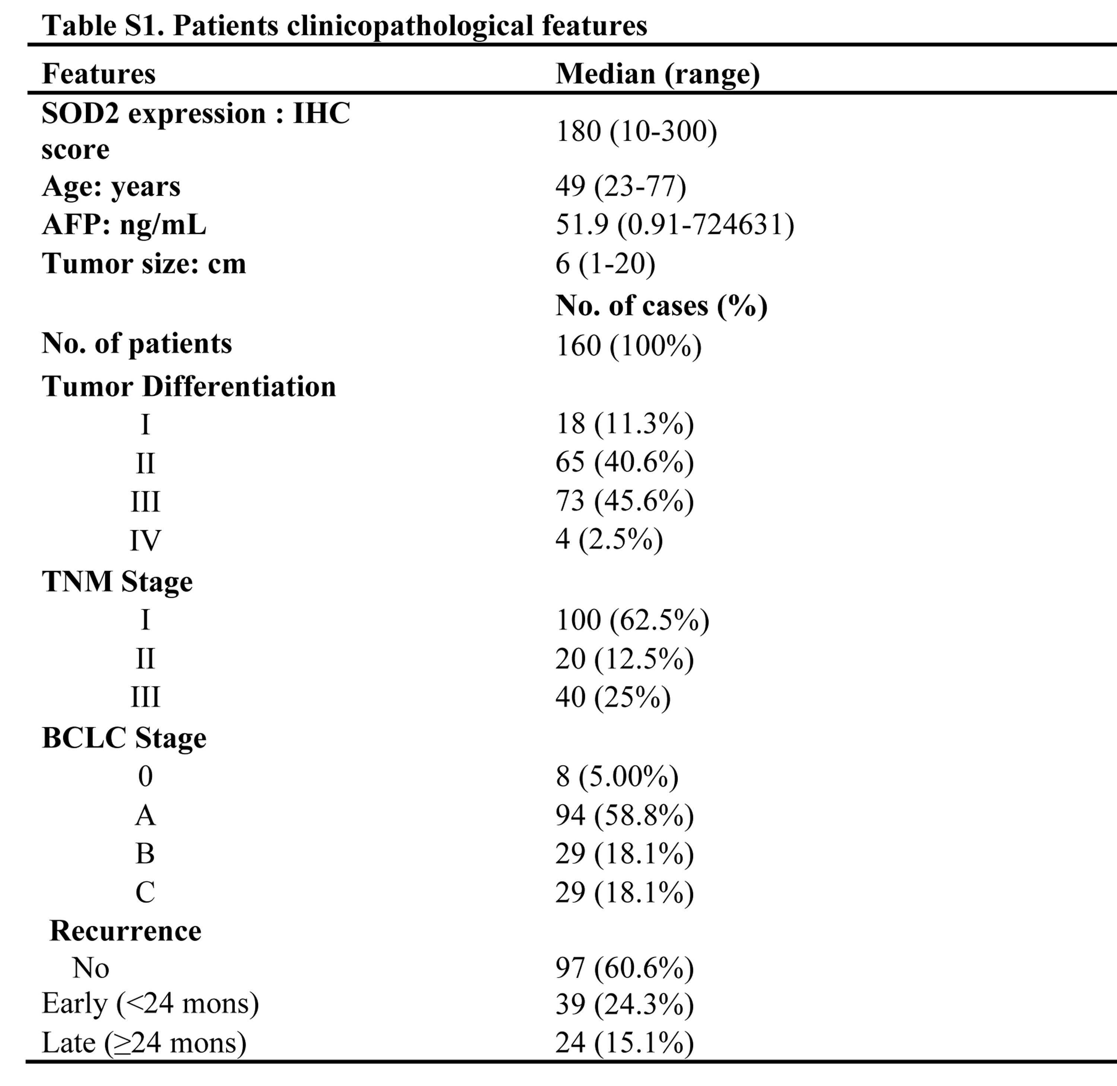

www.impactaging.com 3 AGING, May 2016, Vol. 8 No.5